# Project: Analyzing a Market Test by Oluwatosin Amosu

**Section Format:** Round Roasters is an upscale coffee chain with locations in the western United States of America. The past few years have resulted in stagnant growth at the coffee chain, and a new management team was put in place to reignite growth at their stores. The first initiative by the new team is to conduct an experiment about their new product.

As the business analyst of Round Roasters Company, I’ve been asked to analyze the results of the experiment **to determine whether the menu changes should be applied to all stores**. The predicted impact to profitability should be enough to justify the increased marketing budget: at least 18% increase in profit growth compared to the comparative period while compared to the control stores; otherwise known as incremental lift.

## **Step 1: Planning the Analysis**

1. What is the performance metric you’ll use to evaluate the results of your test?

The performance metric used to evaluate the results of the test is Gross_Margin.

1. What is the test period?

Test period is 2016-April-29 to 2016-July-21

1. At what level (day, week, month, etc.) should the data be aggregated?

The data will be aggregated at the weekly level since we are given 12 periods for the trend and seasonality.

## **Step 2: Clean Up Your Data**

## Here is the data cleaning stage where the correct data types were used, required data ranges were filtered to include 52 weeks of data + 12 weeks period for trends and seasonality + 12 weeks for the test period making a total of 76 weeks as a requirement from the AB trend tool in Alteryx. Furthermore, the data was aggregated to weekly level.

## **Step 3: Match Treatment and Control Units***.*

The trend and seasonality variables were used along with a control variable to match two control units to each treatment unit.

1. What control variables should be considered? Note: Only consider variables in the RoundRoastersStore file.

The control variables considered are Sq_Ft and Sales against the performance metric-gross_margin.

1. What is the correlation between each potential control variable and your performance metric?

The correlation between gross margin and sq_ft is low @ -0.024224 while that of sales against gross_margin is high @ 0.990978.

1. What control variables will you use to match treatment and control stores?

The control variable that will be used to match treatment and control stores is the Avg_monthSales because it has high correlation to the performance metric gross_margin. Generally, we want to select variable(s) that has the highest correlation to the target variable or the performance metric in this case.

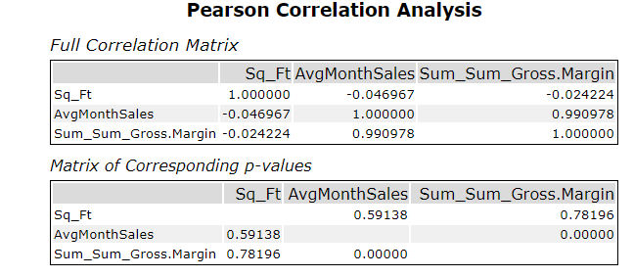

Figure 1.0: Correlation Analysis of potential control variables.

1. Please fill out the table below with your treatment and control stores pairs:

|  |  |  |
| --- | --- | --- |
| Treatment Store | Control Store 1 | Control Store 2 |
| 1664 | 7162 | 8112 |
| 1675 | 1580 | 1807 |
| 1696 | 1964 | 1863 |
| 1700 | 2014 | 1630 |
| 1712 | 8162 | 7434 |
| 2288 | 9081 | 2568 |
| 2293 | 12219 | 9524 |
| 2301 | 3102 | 9238 |
| 2322 | 2409 | 3235 |
| 2341 | 12536 | 2383 |

## Fig 2.0: Control-Treatment Stores pairs

## Step 4: Analysis and Writeup

*Conduct your A/B analysis and create a short report outlining your results and recommendations. (250 words limit)*

*Answer these questions. Be sure to include visualizations from your analysis:*

1. What is your recommendation - Should the company roll out the updated menu to all stores?

Yes, the company should roll out the updated menu to all the stores.

1. What is the lift from the new menu for West and Central regions (include statistical significance)?

From Fig 3.0 below, the report showed 37.9% improvement at a significance of 99.5%. This means during the experiment, there is average of 37.9% increase in sales in the treatment stores as compared to the control stores for the West region.

In other words, the average lift as a result from introducing the new menu alongside some wine with TV advertisement would be 37.9% per store per week, or approximately $526 per store per week. Also, introducing the new menu would improve gross margin; therefore, the change should be rolled out across all stores.

The last box shows the significance level of the T-Test which is 99.5%. This is 1-p level and can be interpreted that the test is highly significant or that it is unlikely that the newly introduce menu did not increase sales.

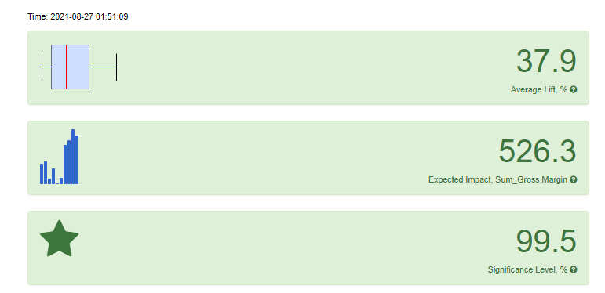

Fig 3.0: Interactive dashboard for West region

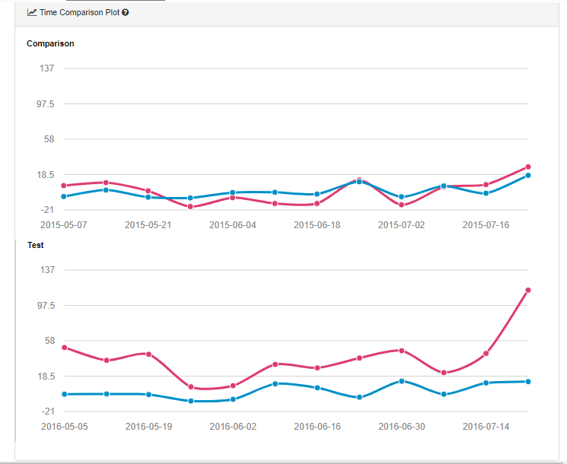

Fig 3.1: Time Comparison plot

The time comparison plot compares the sales trend both before and after the implementation of the T-Test. It can be seen above that the treatment stores and control stores had roughly similar sales during the historical comparative period for the one on top but once the experiment started, there was considerable increase or lift in the sales of the new menu for the treatment stores as compared to the control stores. This is shown below the comparison curve as the test curve in Fig 3.1.

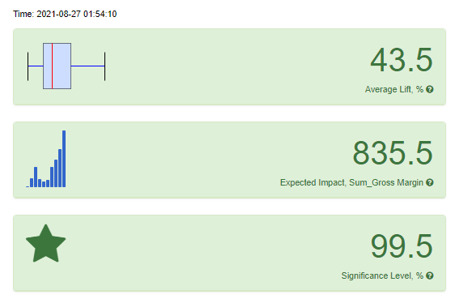

Figure 4.0: Interactive dashboard for the Central

From the above, the lift percentage is 43.5% which means on an average, there is 36.3% increase in sales per store per week. The next box shows the expected impact in sales if the treatment were applied. This means there will be approximately $836 increase in sales per store per week. Additionally, this impact the gross_margin also thus, the new menu would be rolled out to stores in the Central regions as well.

The last box is the significance level of the T-Test which is 99.5% and this tells us that the experiment is highly significant.

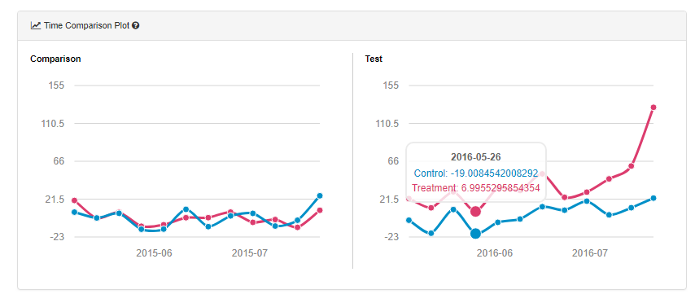

Figure 4.1: Time Comparison Plot

From Fig 4.1, in the same manner there were similar sales of both the treatment and the control stores at the Central regions but once the experiment started, there was massive increase in sales or lift of the treatment stores compared to that of control stores.

1. What is the lift from the new menu overall?

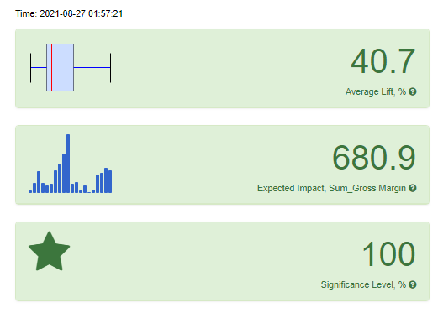

Fig 5.0: Interactive dashboard for the Overall new menu

Management wants to know the impact on profitability if new menu should be rolled out to all of their stores in order to maximize profit thus the need to calculate the lift % for the overall new menu. From the interactive dashboard above, the lift is 40.7% which means that on an average, there would be 40.7% increase in treatment stores if the new menu is rolled out to all of Round Roasters Stores. Additionally, the expected increase in sales is $681 per store per week with a significance level of 100%.

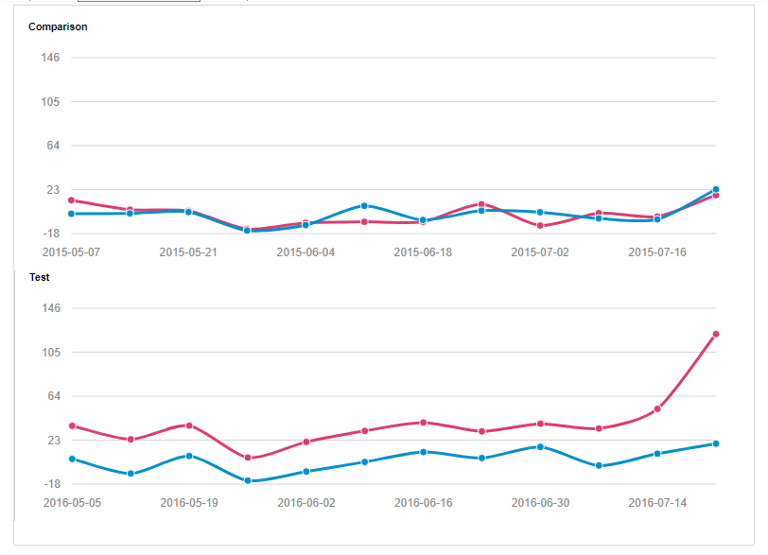

Fig 5.1: Time Plot for the Overall New Menu

This is the time plot which in summary signifies increase in sales of the treatment stores once the experiment started prior to the start of the experiment where there is similar trend in sales of both treatment and control stores.